| Cybersecurity |
| --- |
| Penetration Test Report |

Rekall Corporation

Penetration Test Report

# 

## Confidentiality Statement

This document contains confidential and privileged information from Rekall Inc. (henceforth known as Rekall). The information contained in this document is confidential and may constitute inside or non-public information under international, federal, or state laws. Unauthorized forwarding, printing, copying, distribution, or use of such information is strictly prohibited and may be unlawful. If you are not the intended recipient, be aware that any disclosure, copying, or distribution of this document or its parts is prohibited.

Table of Contents

Confidentiality Statement 2

Contact Information 4

Document History 4

Introduction 5

Assessment Objective 5

Penetration Testing Methodology 6

Reconnaissance 6

Identification of Vulnerabilities and Services 6

Vulnerability Exploitation 6

Reporting 6

Scope 7

Executive Summary of Findings 8

Grading Methodology 8

Summary of Strengths 9

Summary of Weaknesses 9

Executive Summary Narrative 10

Summary Vulnerability Overview 13

Vulnerability Findings 14

# 

## Contact Information

| **Company Name** | Beatles, LLC |
| --- | --- |
| **Contact Name** | Dmytro Goncharov |
| **Contact Title** | Mr. |

## 

## Document History

| **Version** | **Date** | **Author(s)** | **Comments** |
| --- | --- | --- | --- |
| 001 | 12/07/2023 | Dmytro Goncharov | report |

# 

## Introduction

In accordance with Rekall policies, our organization conducts external and internal penetration tests of its networks and systems throughout the year. The purpose of this engagement was to assess the networks’ and systems’ security and identify potential security flaws by utilizing industry-accepted testing methodology and best practices.

For the testing, we focused on the following:

* Attempting to determine what system-level vulnerabilities could be discovered and exploited with no prior knowledge of the environment or notification to administrators.
* Attempting to exploit vulnerabilities found and access confidential information that may be stored on systems.
* Documenting and reporting on all findings.

All tests took into consideration the actual business processes implemented by the systems and their potential threats; therefore, the results of this assessment reflect a realistic picture of the actual exposure levels to online hackers. This document contains the results of that assessment.

### Assessment Objective

The primary goal of this assessment was to provide an analysis of security flaws present in Rekall’s web applications, networks, and systems. This assessment was conducted to identify exploitable vulnerabilities and provide actionable recommendations on how to remediate the vulnerabilities to provide a greater level of security for the environment.

We used our proven vulnerability testing methodology to assess all relevant web applications, networks, and systems in scope.

Rekall has outlined the following objectives:

Table 1: Defined Objectives

| **Objective** |
| --- |
| Find and exfiltrate any sensitive information within the domain. |
| Escalate privileges. |
| Compromise several machines. |

# 

## Penetration Testing Methodology

### Reconnaissance

### 

We begin assessments by checking for any passive (open source) data that may assist the assessors with their tasks. If internal, the assessment team will perform active recon using tools such as Nmap and Bloodhound.

### Identification of Vulnerabilities and Services

We use custom, private, and public tools such as Metasploit, hashcat, and Nmap to gain perspective of the network security from a hacker’s point of view. These methods provide Rekall with an understanding of the risks that threaten its information, and also the strengths and weaknesses of the current controls protecting those systems. The results were achieved by mapping the network architecture, identifying hosts and services, enumerating network and system-level vulnerabilities, attempting to discover unexpected hosts within the environment, and eliminating false positives that might have arisen from scanning.

### Vulnerability Exploitation

Our normal process is to both manually test each identified vulnerability and use automated tools to exploit these issues. Exploitation of a vulnerability is defined as any action we perform that gives us unauthorized access to the system or the sensitive data.

### Reporting

Once exploitation is completed and the assessors have completed their objectives, or have done everything possible within the allotted time, the assessment team writes the report, which is the final deliverable to the customer.

# 

## Scope

Prior to any assessment activities, Rekall and the assessment team will identify targeted systems with a defined range or list of network IP addresses. The assessment team will work directly with the Rekall POC to determine which network ranges are in-scope for the scheduled assessment.

It is Rekall’s responsibility to ensure that IP addresses identified as in-scope are actually controlled by Rekall and are hosted in Rekall-owned facilities (i.e., are not hosted by an external organization). In-scope and excluded IP addresses and ranges are listed below.

# 

# 

## Executive Summary of Findings

## 

### Grading Methodology

Each finding was classified according to its severity, reflecting the risk each such vulnerability may pose to the business processes implemented by the application, based on the following criteria:

**Critical**: Immediate threat to key business processes.

**High**: Indirect threat to key business processes/threat to secondary business processes.

**Medium**: Indirect or partial threat to business processes.

**Low**: No direct threat exists; vulnerability may be leveraged with other vulnerabilities.

Informational: No threat; however, it is data that may be used in a future attack.

As the following grid shows, each threat is assessed in terms of both its potential impact on the business and the likelihood of exploitation:

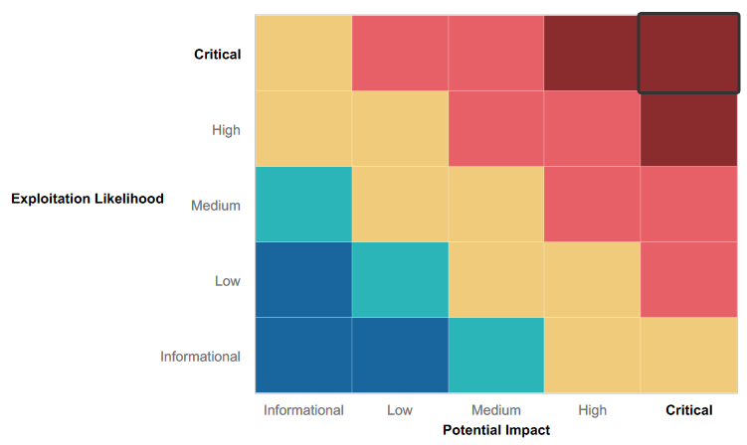

### 

### Summary of Strengths

While the assessment team was successful in finding several vulnerabilities, the team also recognized several strengths within Rekall’s environment. These positives highlight the effective countermeasures and defenses that successfully prevented, detected, or denied an attack technique or tactic from occurring.

* Networks are properly organized
* Web application in good shape and running
* Windows network use Domain Security

Different networks are separated from each other

* No financial documentation being found

### Summary of Weaknesses

We successfully found several critical vulnerabilities that should be immediately addressed in order to prevent an adversary from compromising the network. These findings are not specific to a software version but are more general and systemic vulnerabilities.

* Weak password management and password culture
* Publicly accessible critical information
* Weak code for the Web application (XSS, SQL, CL, LFI, PHP injections possible)
* Outdated and unpatched software on Linux network
* Outdated and unpatched software on Windows network

## Executive Summary

According to the given objectives our team has made several tests and probes which falls in 3 categories:

* Web Application test
* Linux network test
* Windows network test.

Here is a summary for each of them.

1. **Application security**. We have been tasked to explore a web application at the address 192.168.14.35 and there were several vulnerabilities revealed:

* XSS reflected code possibility

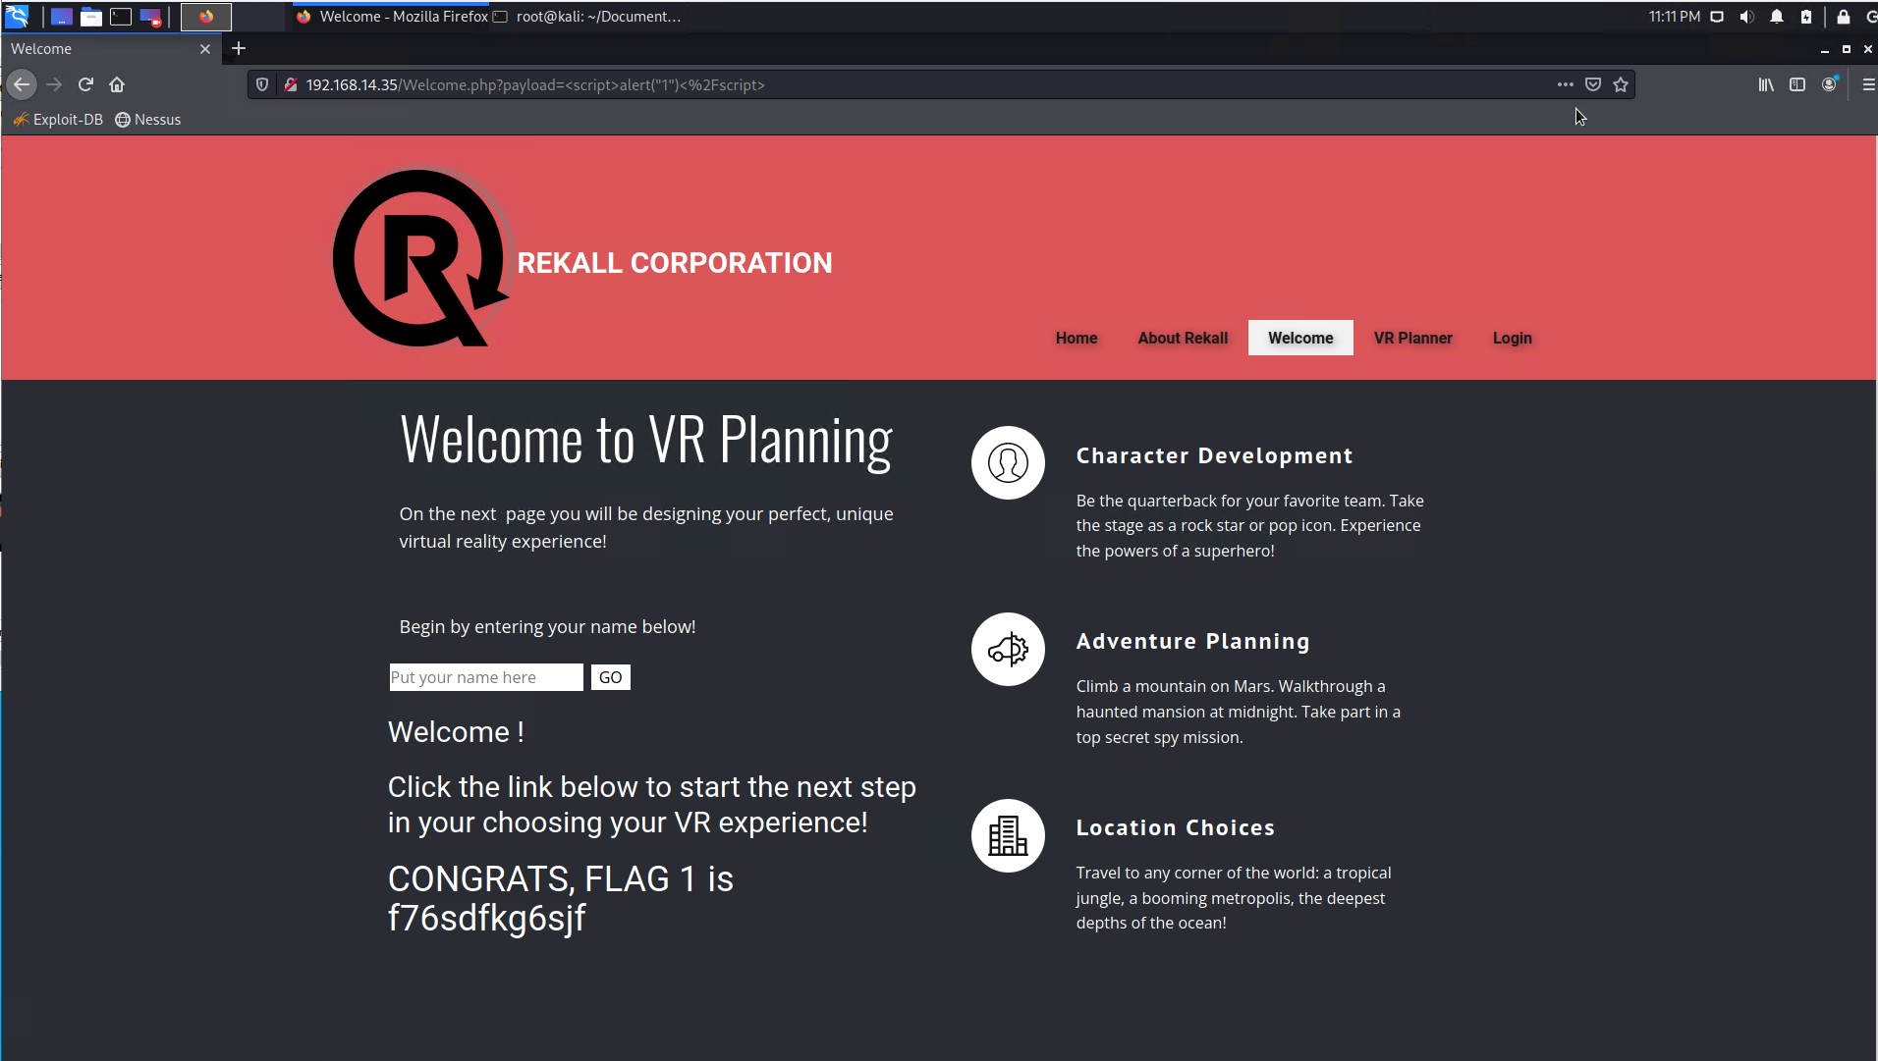

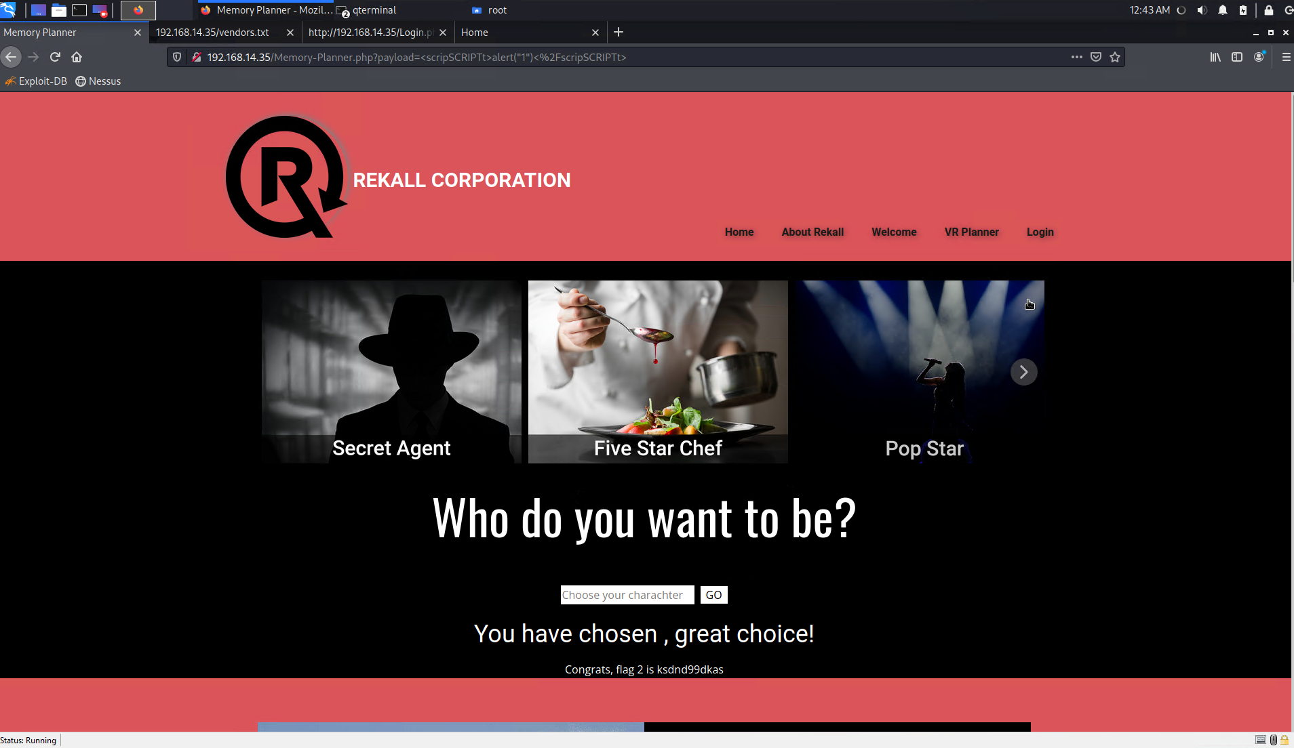

* XSS stored code possibility

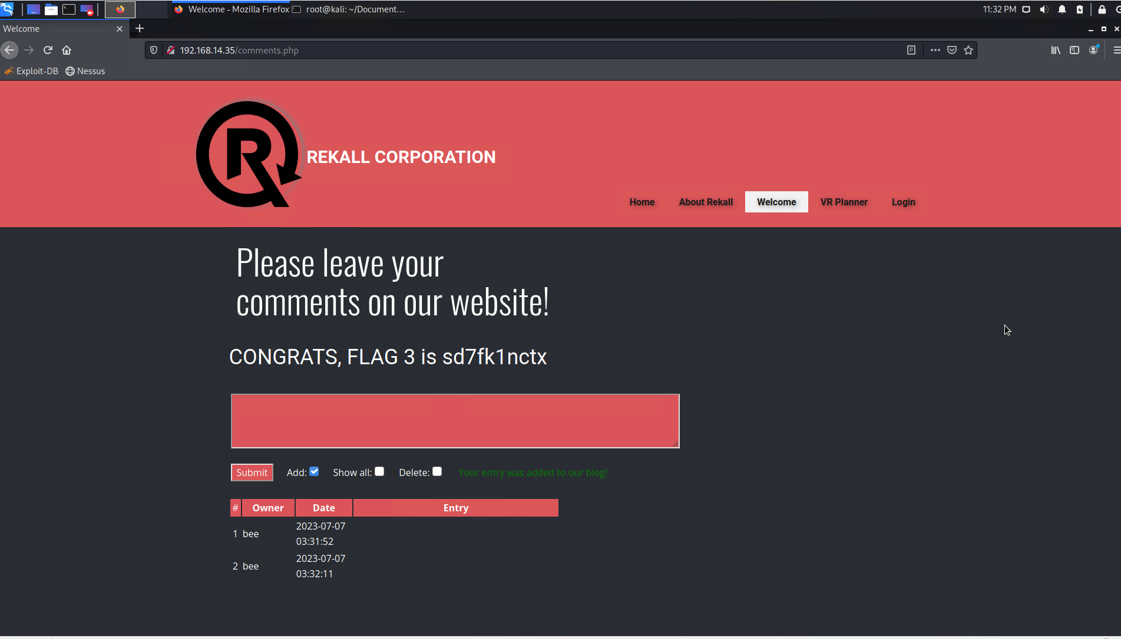

* sensitive data exposure under HTTP header

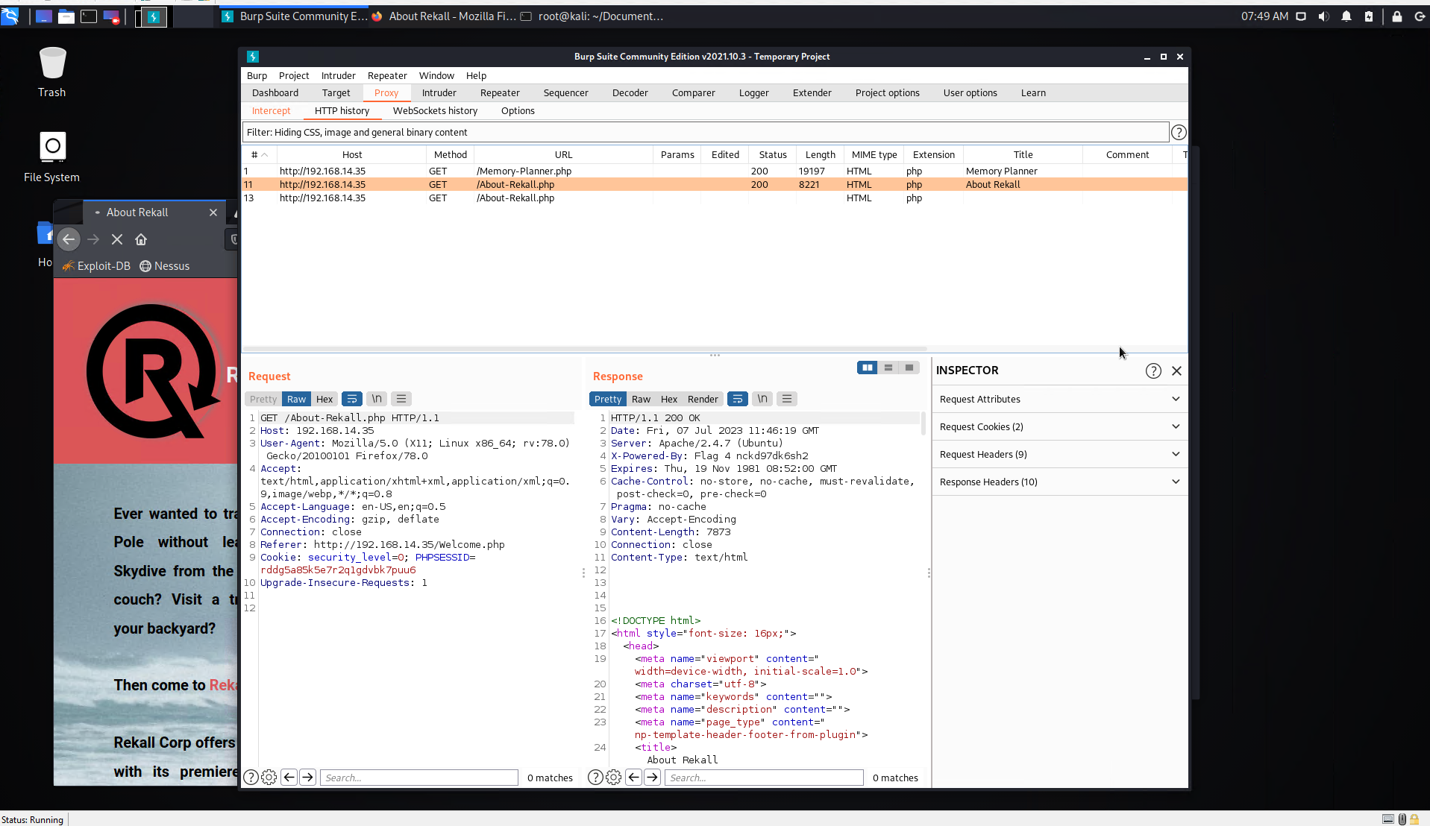

* Local File Inclusion vulnerability

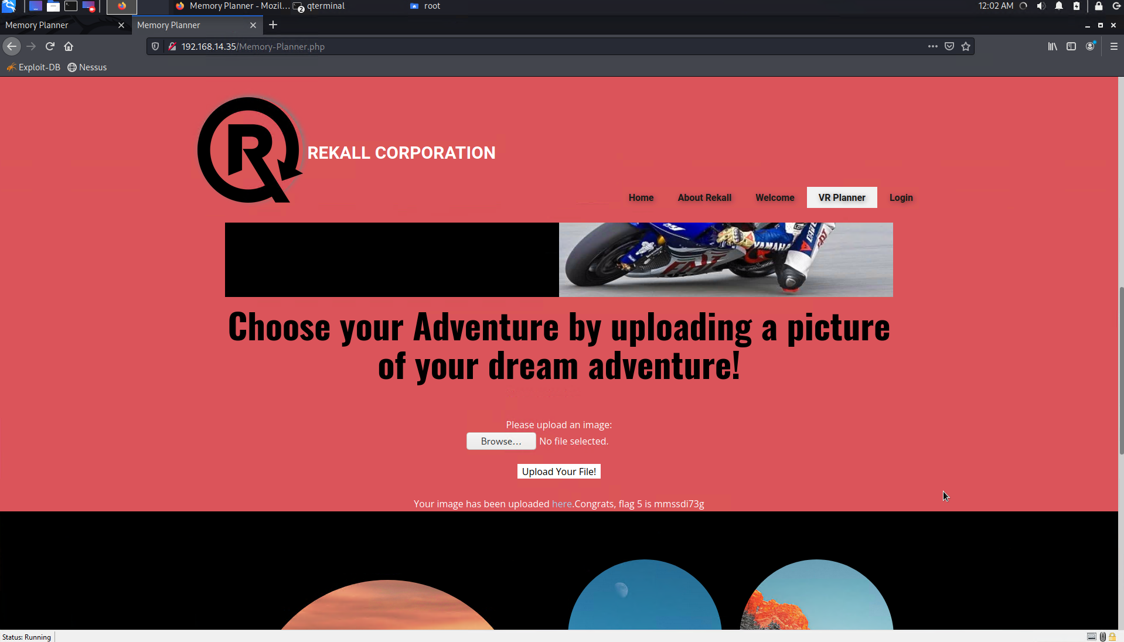

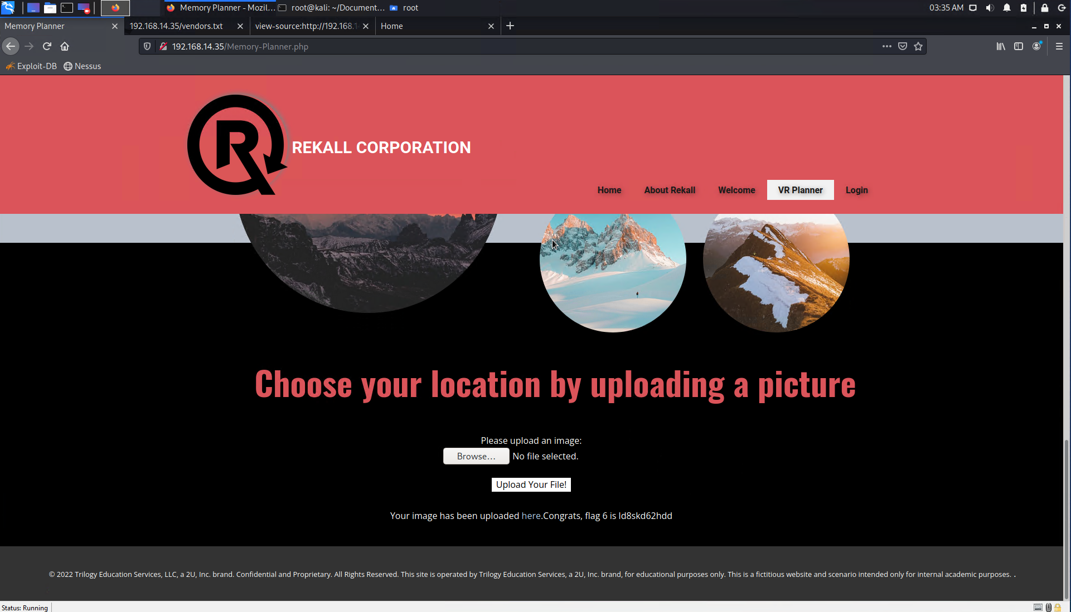

* SQL injection vulnerability

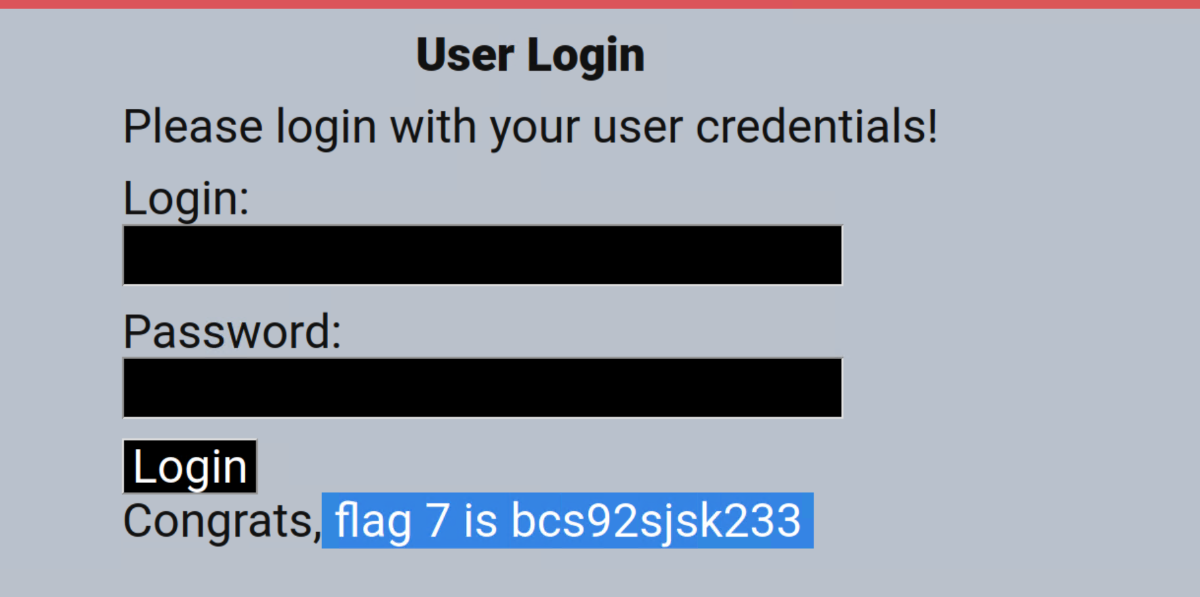

* sensitive data exposure (password and loging in HTML file)

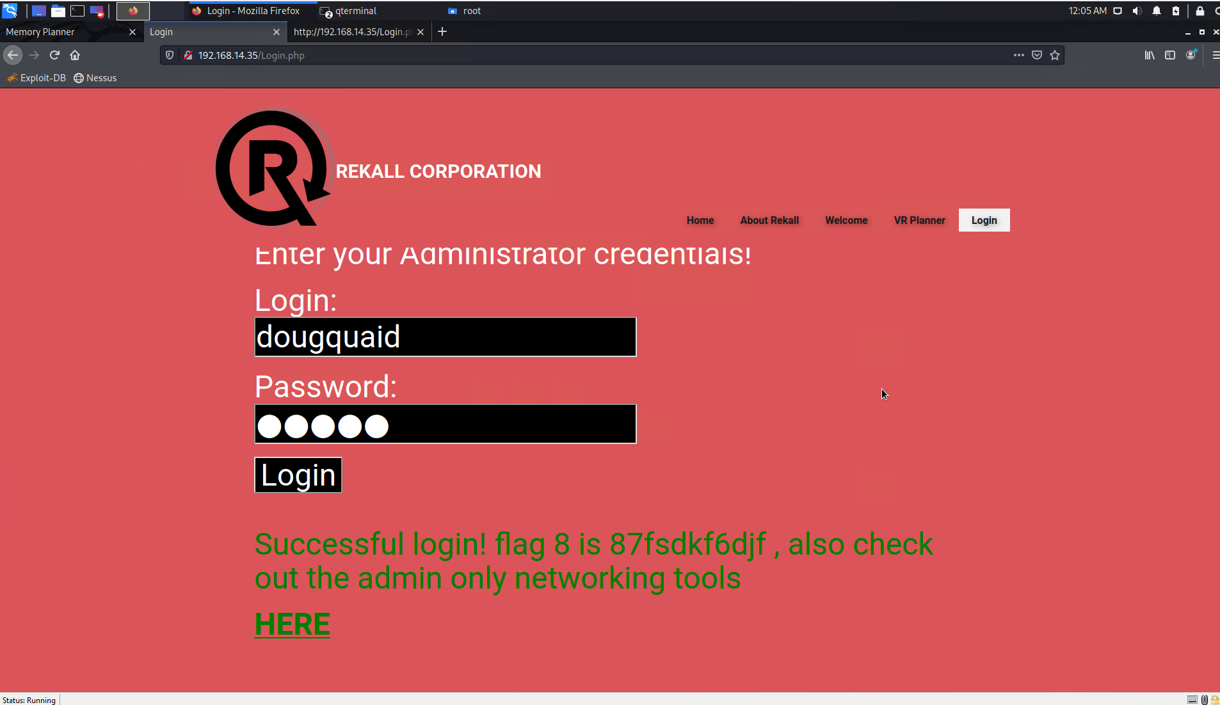

* sensitive data exposure (file robots.txt)

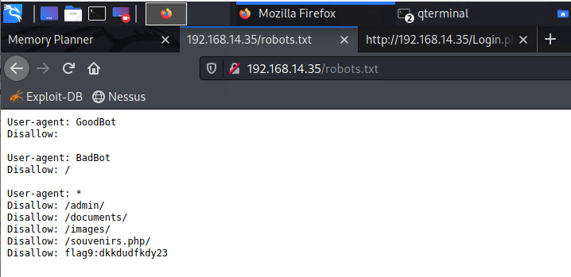

* command injection vulnerability

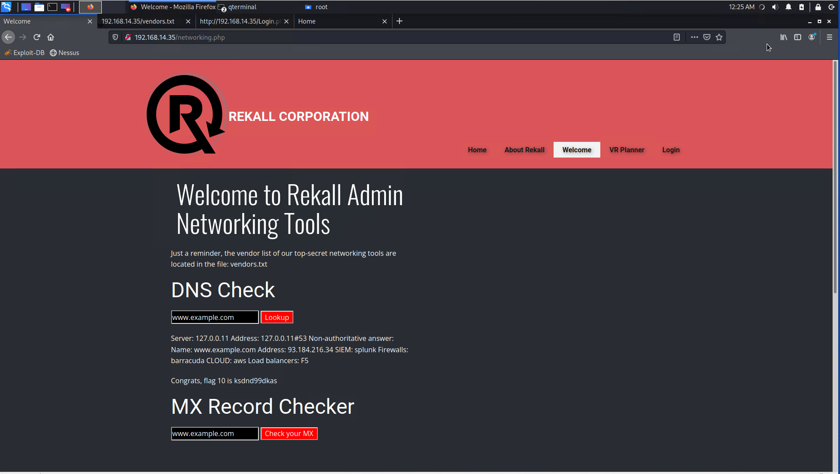

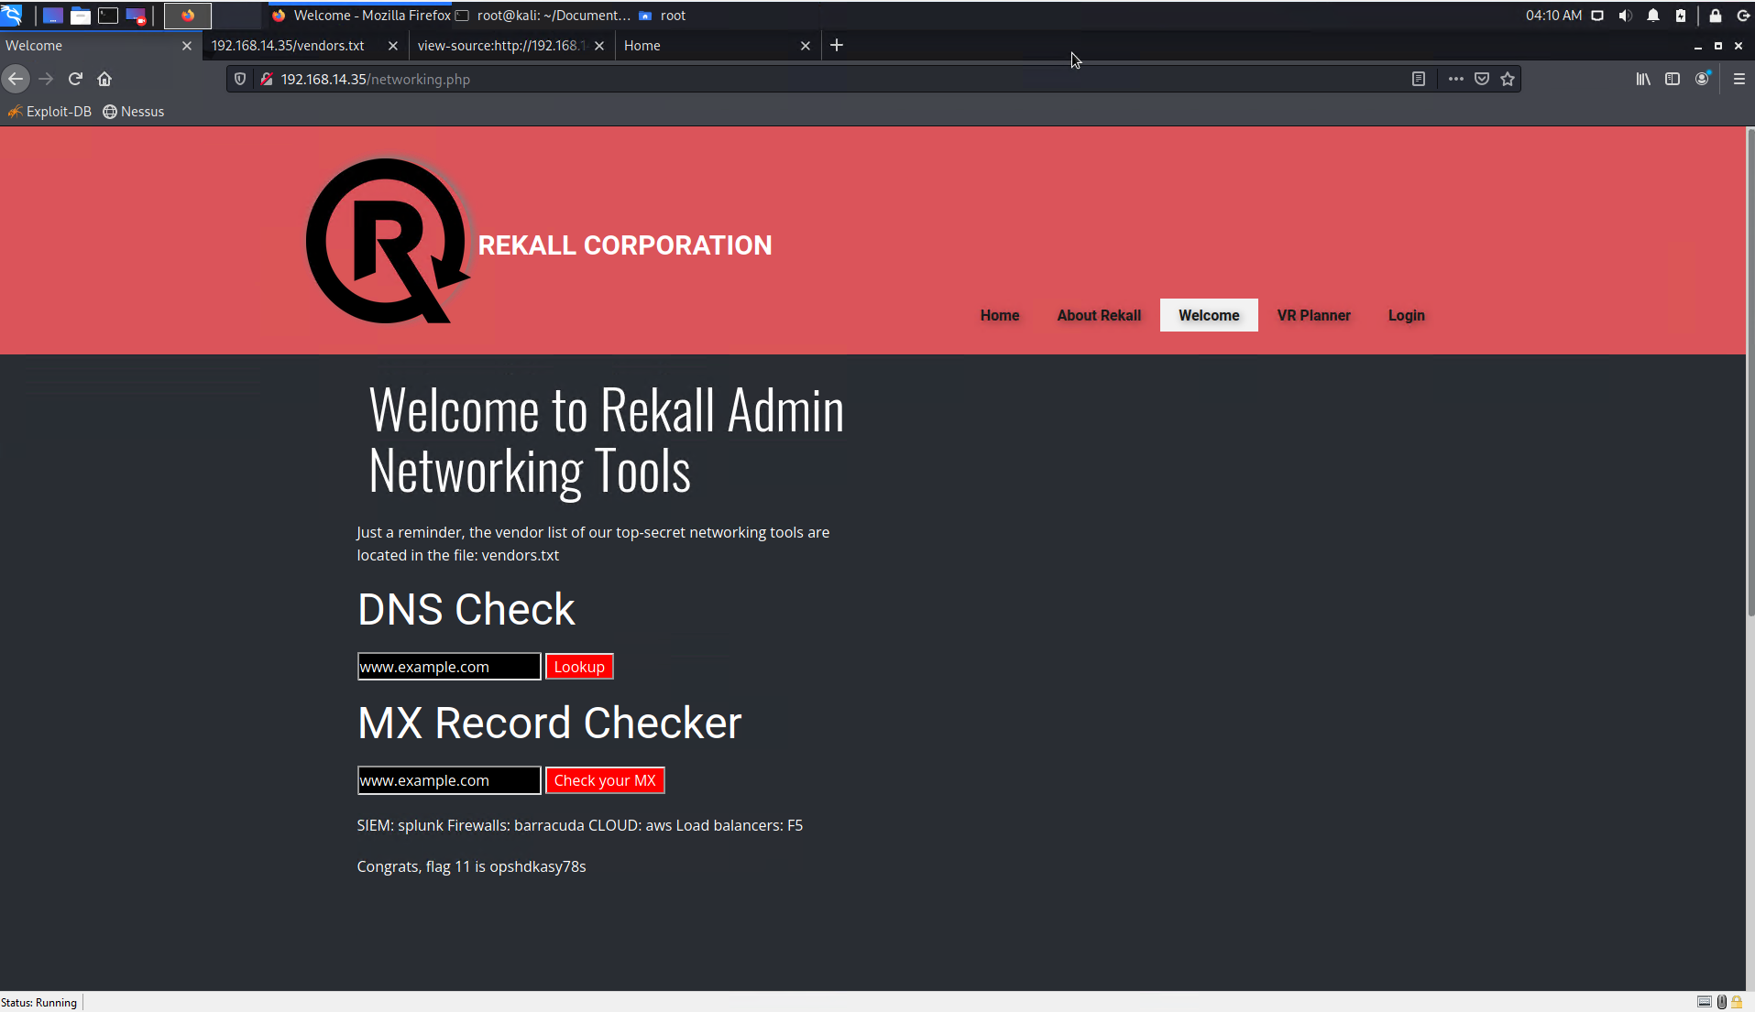

* brute force attack possible

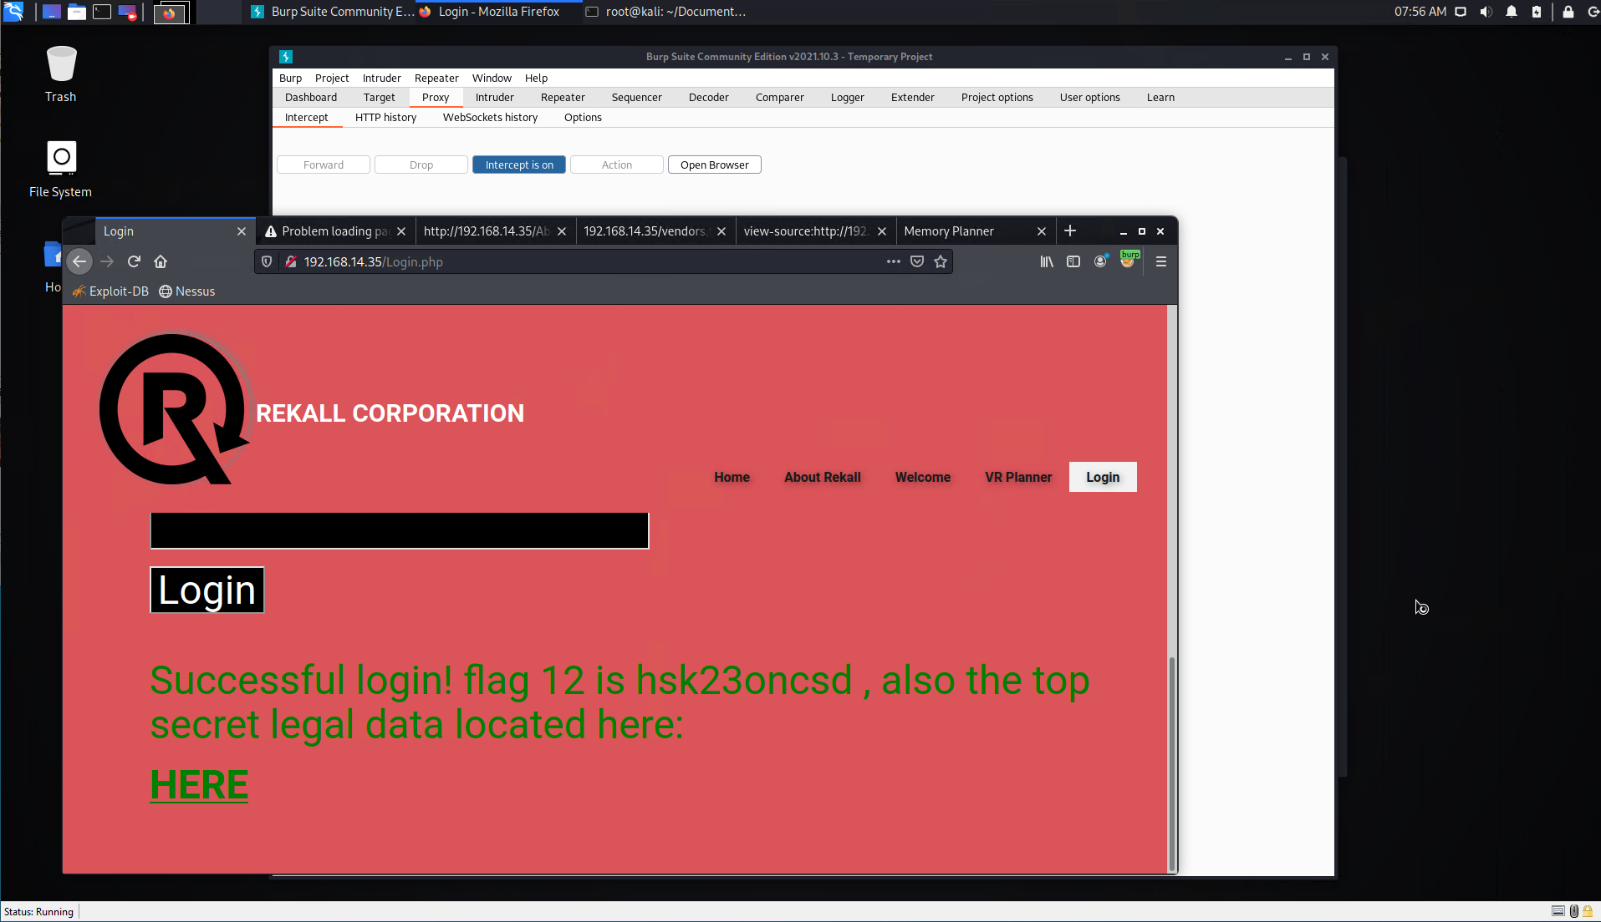

* PHP injection vunerability

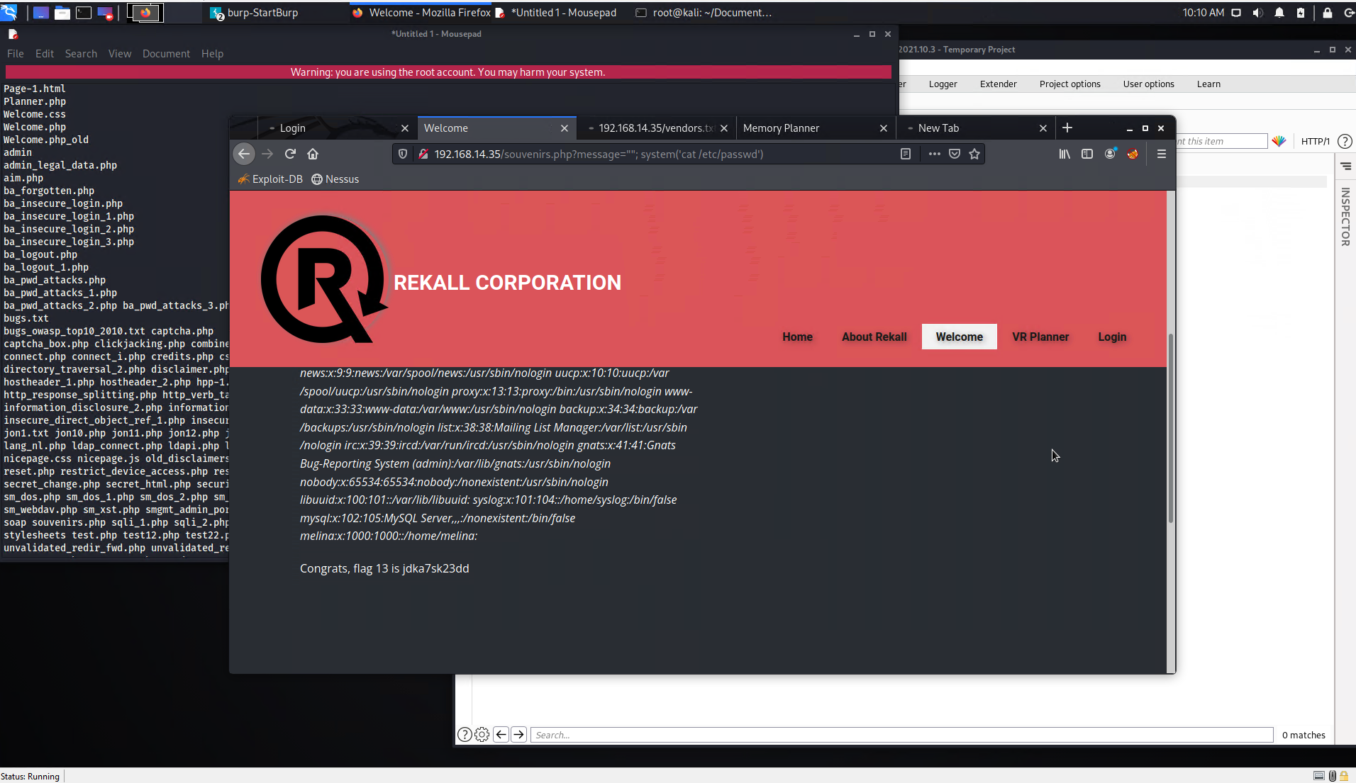

* session management control weak

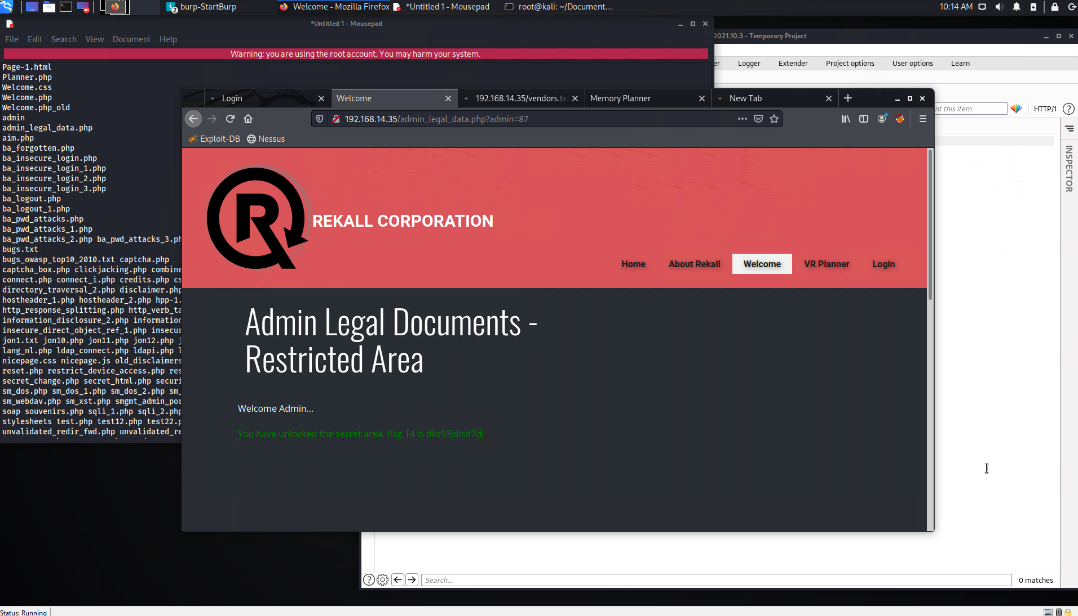

* directory traversal possible

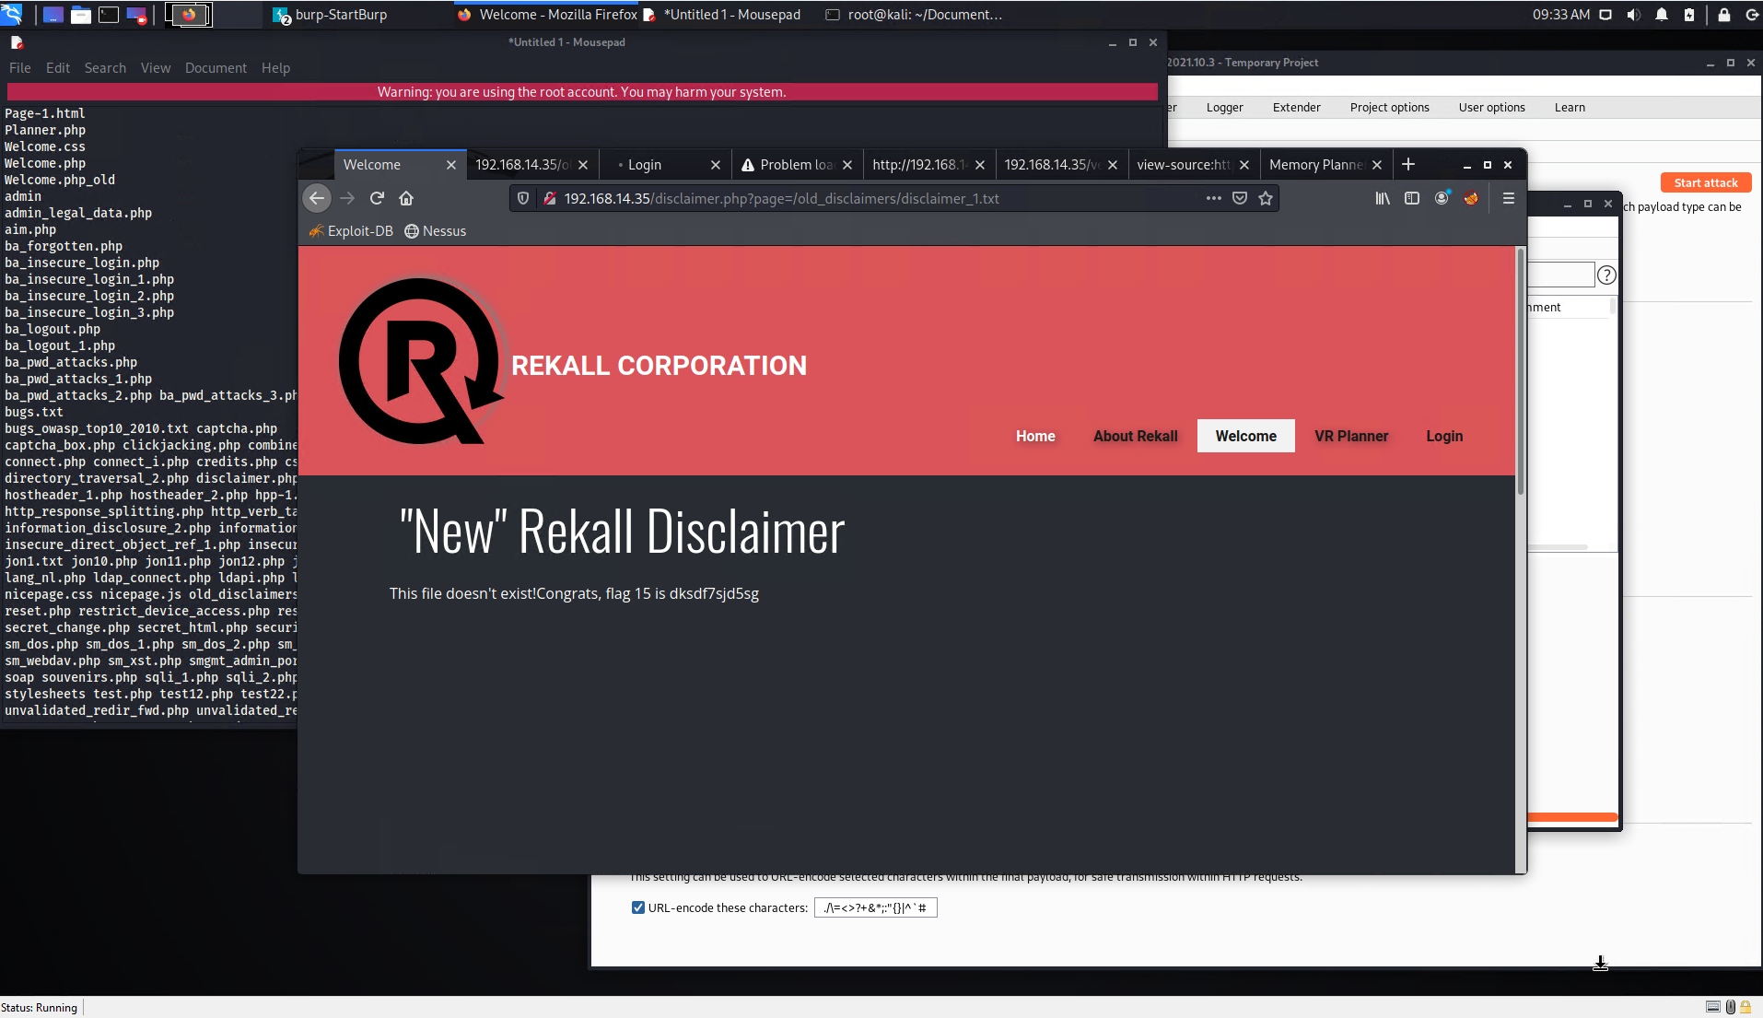

1. **Linux network security**

For our testing we have got IP range 192.168.1.0/24

There were discovered 5 Linux machines with IPs ending 10, 11, 12, 13, 14.

Open source search revealed publicly available sensitive information

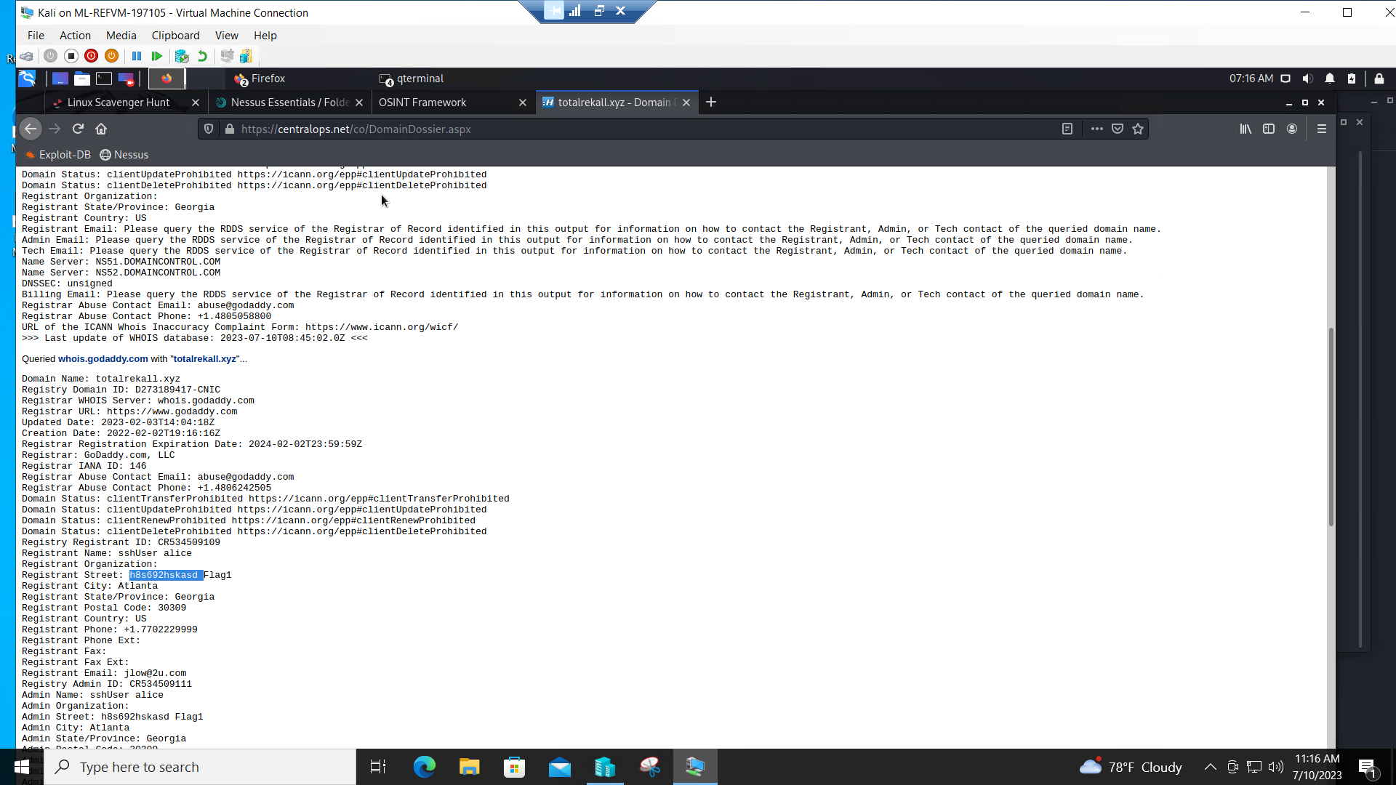

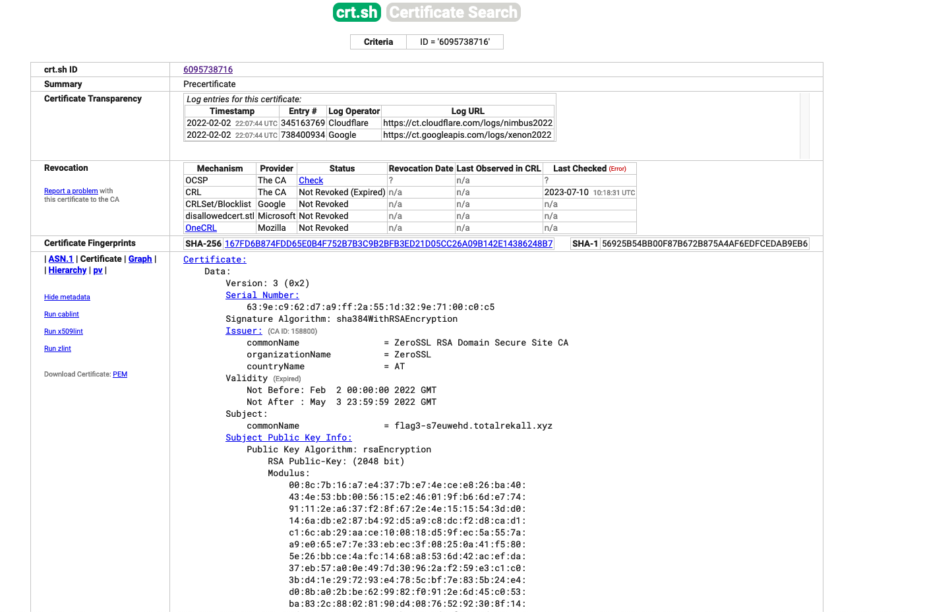

security issue - publicly available sensitive information.

Further technical exploration of your network revealed the following:0

* Your machine ending 13 run a vulnerable software called Drupal with a serious security hole called CVE-2019-6340. We have exploited the vulnerability and got access to this machine (flag 11)



* machine ending 10 run Apache server with Tomcat security vulnerability known as CVE-2017-12617. This allowed us to get over the machine and get full access to it’s information

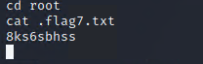

* machine ending 11 runs another Apache server software with “Shellshock” vulnerability, which allows us to get over the machine and reveal all information on it. (flag 8 and 9)
* machine ending 12, has vulnerability called Struts - CVE-2017-5638

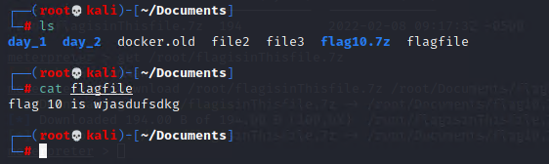

* machine ending 14. We used publicly stored credentials (see at the beginning here) to get an access to this machine. For further investigation this machine happened to have a vulnerability CVE-2019-6340 which allowed us to elevate our privileges and get a full control on it

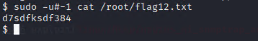

1. **Windows network security**

For our testing we have been given an IP range 172.22.117.0/24.

We started from searching open sources and found found a public page, belonging to Rekall corp., with encrypted credentials.

## 

encrypted message was successfully cracked what gave us the following symbol set: Tanya4life

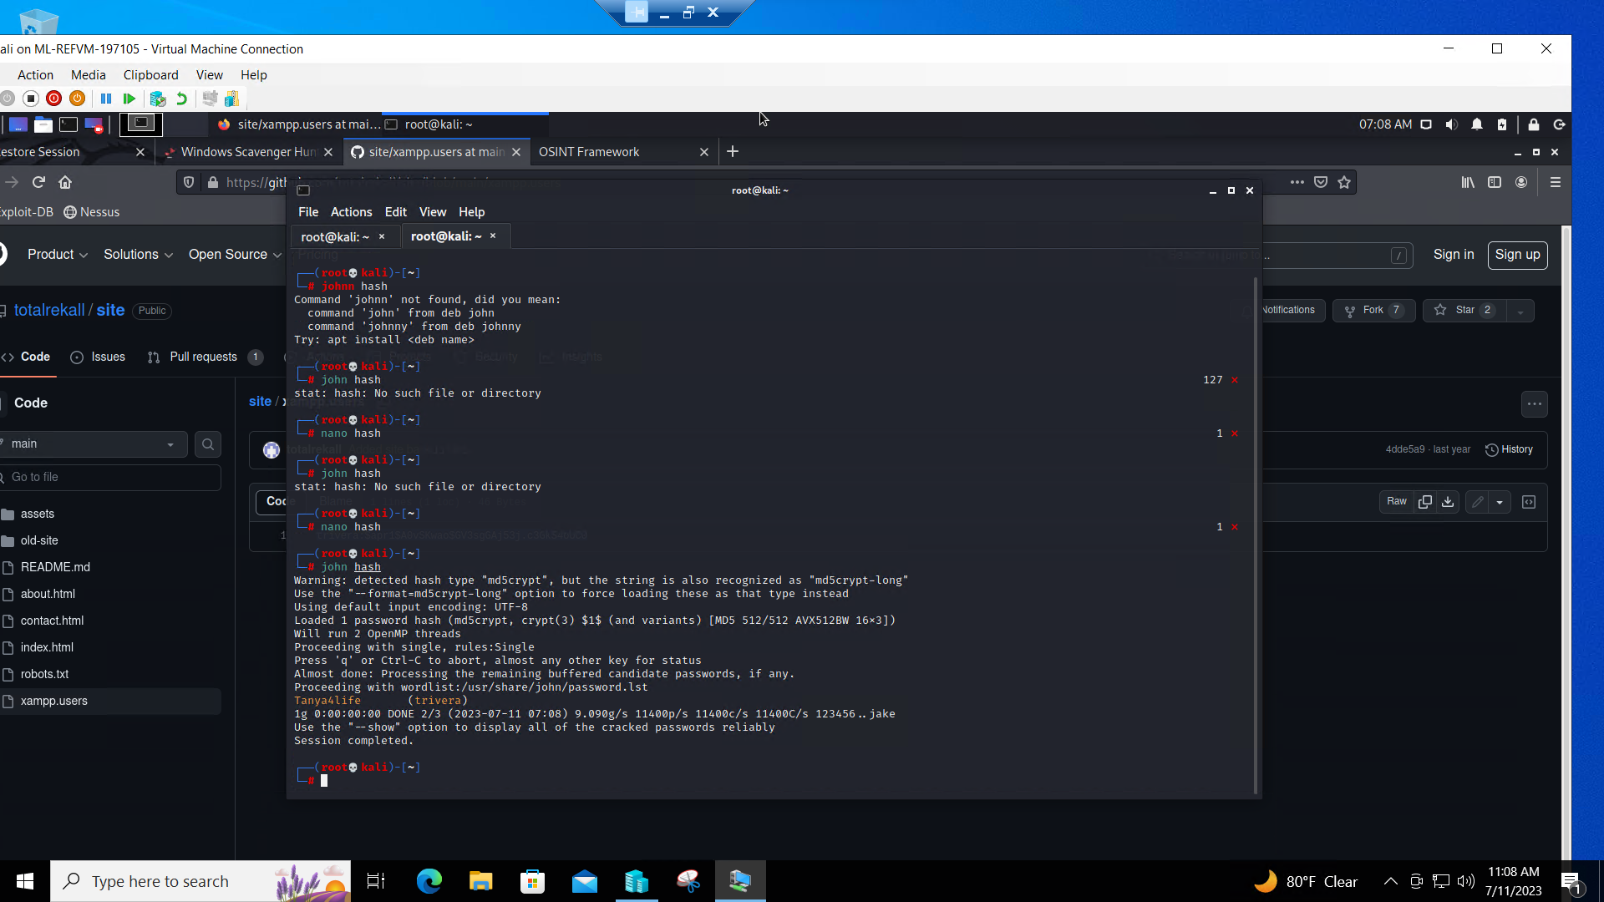

We scanned the given network and discovered 2 machines with IPs 172.22.117.20 (Windows10 machine)and 172.22.117.10 (Windows Server2019 machine).

Windows10 has several ports opened which led us to several vulnerabilities discoveries.

Namely: port 21 ftp, port 80 http, port 110 SLMAIL

exploring port 80, we’ve come to a login page. We used publicly discovered credentials (trivera/Tanya4life) and were able to enter the web page. Discovered problem - WEAK/Publicly stored password

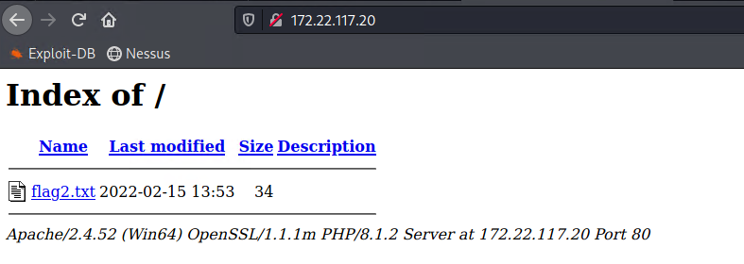

Your ftp-server appeared to support anonymous connection. This is very dangerous vulnerability so anybody can connect to the server and get any of stored files

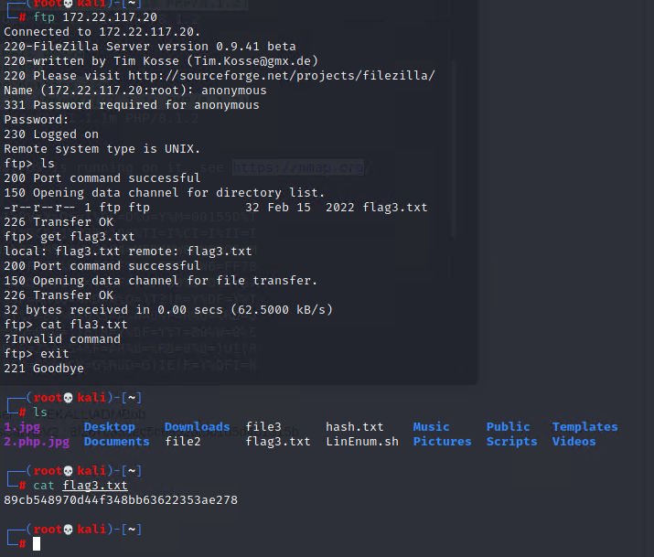

WIndows10 machine’s email service utilizes vulnerable software called SLMAIL SLMAIL has an old-known security hole called CVE-2003-0264 which allows unauthorized access to affected machines.

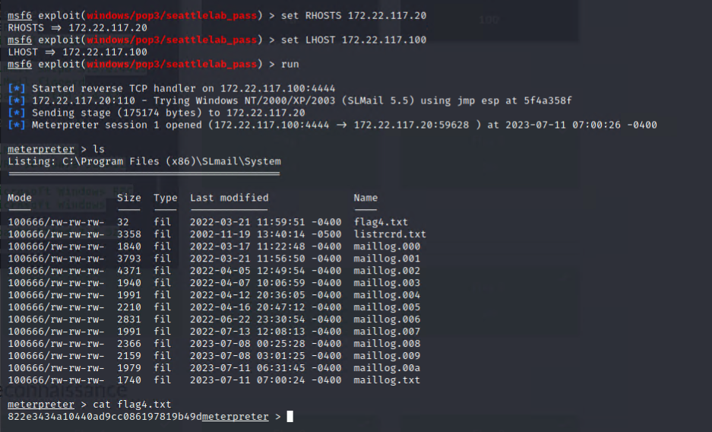

as soon as we got access to the machine, we could be able to use task scheduler and expand our persistence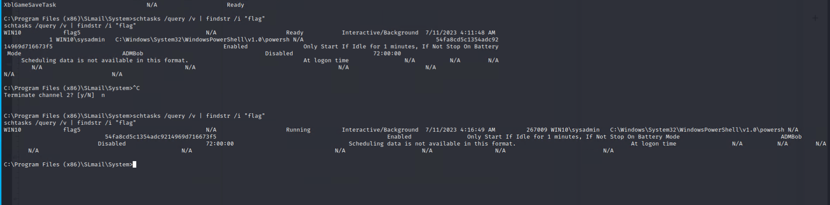

we also managed to crack passwords for other users of the Windows10 machine

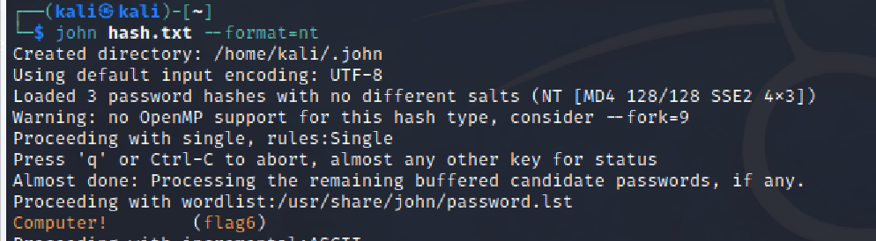

## 

## 

## exploring Windows10 machine we cracked cache damp and got login credentials for Administrator user to a Server19 machine

## 

## 

## 

## 

## As soon as we got credentials we acquired the Server machine.

## 

## 

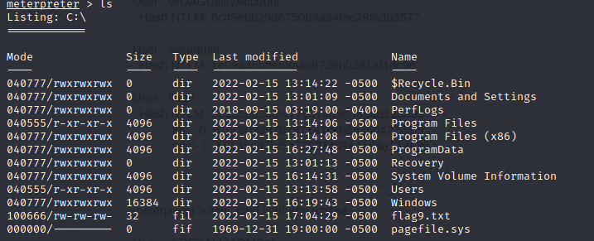

## 

## 

## 

## So, full scope of objectives was completed.

## Summary Vulnerability Overview

| **Vulnerability** | **Severity** |
| --- | --- |
| weak password policy | **critical** |
| publicly exposed sensitive data | **high** |
| weak web application code | **critical** |
| linux machines ending 10.11.12.13 - outdated and unpatched software | **critical** |
| linux machine ending 14 - unpatched | **high** |
| windows10 machine - outdated unpatched software | **critical** |
| windows Server machine - unpatched software | **high** |
| unnecessary ports open | **medium** |
| unnecessary services running | **medium** |
| web application resides on a non-dedicated machine | **medium** |
|  |  |
|  |  |
|  |  |
|  |  |
|  |  |
|  |  |
|  |  |
|  |  |
|  |  |
|  |  |
|  |  |

The following summary tables represent an overview of the assessment findings for this penetration test:

| **Scan Type** | **Total** |
| --- | --- |
| Hosts | 8 |
| Ports |  |

| **Exploitation Risk** | **Total** |
| --- | --- |
| **Critical** | 4 |
| **High** | 3 |
| **Medium** | 3 |
| **Low** | 0 |

## Vulnerability Findings

| **Vulnerability 1** | **Findings** |
| --- | --- |
| **Title** | Weak password policy |
| **Type (Web app / Linux OS / WIndows OS)** | all over |
| **Risk Rating** | critical |
| **Description** | some of the passwords discovered are weak and vulnerable to brute-force attack and even guessing |
| **Images** |  |
| **Affected Hosts** | 192.168.13 (10,11,12,13,14), Windows10, 192.168.14.35 |
| **Remediation** | implement strong password policy with the length of minimum 16 random symbols, implement forced password renewal, consider implementing password keyring software. Prohibit publicly stored password hints. Prohibit same login and password. |

| **Vulnerability 2** | **Findings** |
| --- | --- |
| **Title** | command injections (XSS, SQL, command line, etc) |
| **Type (Web app / Linux OS / WIndows OS)** | Web Application, all user and command inputs |
| **Risk Rating** | critical |
| **Description** | Allows special code injection with the intent to run a script or command which may lead to data leak or unauthorized access. |
| **command string** | <script>alert("hi")</script>  `ok' or 1=1-- `  && cat  ;;||  http://192.168.13.35/souvenirs.php?message=""; system('cat /etc/passwd') |
| **Affected Hosts** | 192.168.14.35,  Welcome.php, Memory-Planner.php, networking.php, |
| **Remediation** | sanitize web pages to filter code and special character input (<>%/?()&|=;), encode data on output so it can’t be interpreted as a command |

| **Vulnerability 3** | **Findings** |
| --- | --- |
| **Title** | HTML code contains sensitive information |
| **Type (Web app / Linux OS / WIndows OS)** | Web Application |
| **Risk Rating** | critical |
| **Description** | sensitive data, login and password publicly accessible through HTML code |
|  |  |
| **Affected Hosts** | 192.168.14.35 |
| **Remediation** | delete sensitive data from the code |

| **Vulnerability 4** | **Findings** |
| --- | --- |
| **Title** | Local File Inclusion |
| **Type (Web app / Linux OS / WIndows OS)** | Web Application |
| **Risk Rating** | critical |
| **Description** | possibility to upload infected file and execute unauthorized code |
| **involved** | php script |
| **Affected Hosts** | 192.168.14.35, file upload |
| **Remediation** | avoid file uploading if possible, use the last version of PHP, blacklist special characters and patterns like php |

| **Vulnerability 5** | **Findings** |
| --- | --- |
| **Title** | Sensitive data exposure |
| **Type (Web app / Linux OS / WIndows OS)** | all over |
| **Risk Rating** | high |
| **Description** | file robots.txt contains sensitive data |
|  |  |
| **Affected Hosts** | 192.168.14.35, linux network, windows network |
| **Remediation** | sanitize the files and websites, |

| **Vulnerability 6** | **Findings** |
| --- | --- |
| **Title** | Poor session management |
| **Type (Web app / Linux OS / WIndows OS)** | Web Application |
| **Risk Rating** | critical |
| **Description** | allows unauthorized access to private data |
|  |  |
| **Affected Hosts** | 192.168.14.35 |
| **Remediation** | expand session ID length to 128 bit key. |

| **Vulnerability 7** | **Findings** |
| --- | --- |
| **Title** | Directory traversal possible |
| **Type (Web app / Linux OS / WIndows OS)** | Web Application |
| **Risk Rating** | critical |
| **Description** | allows attackers to access restricted directories and execute commands outside of the web server's root directory |
| string line | http://192.168.13.35/disclaimer.php?page=old_disclaimers/disclaimer_1.txt |
| **Affected Hosts** |  |
| **Remediation** | filter user inputs, clean old unnecessary files, lock private directories with access rights |

| **Vulnerability 8** | **Findings** |
| --- | --- |
| **Title** | Drupal vulnerability |
| **Type (Web app / Linux OS / WIndows OS)** | Linux OS |
| **Risk Rating** | critical |
| **Description** | allows exploitation with full machine control |
| Metasploit module | unix/webapp/drupal_restws_unserialize |
| **Affected Hosts** | 192.168.13.13 |
| **Remediation** | software update and patch, avoid Drupal if possible, properly configure software |

| **Vulnerability 9** | **Findings** |
| --- | --- |
| **Title** | Apache Tomcat vulnerability |
| **Type (Web app / Linux OS / WIndows OS)** | Linux OS |
| **Risk Rating** | critical |
| **Description** | allows exploitation with full machine control |
| metasploit module | multi/http/tomcat_jsp_upload_bypass |
| **Affected Hosts** | 192.168.13.10 |
| **Remediation** | software update and patch, avoid Tomcat at all, properly configure software |

| **Vulnerability 10** | **Findings** |
| --- | --- |
| **Title** | Shellshock vulnerability |
| **Type (Web app / Linux OS / WIndows OS)** | Linux OS |
| **Risk Rating** | critical |
| **Description** | allows exploitation with full machine control |
| metasploit module | exploit/multi/http/apache_mod_cgi_bash_env_exec |
| **Affected Hosts** | 192.168.13.11 |
| **Remediation** | software update and patch, properly configure software |

| **Vulnerability 11** | **Findings** |
| --- | --- |
| **Title** | Apache Struts vulnerability |
| **Type (Web app / Linux OS / WIndows OS)** | Linux OS |
| **Risk Rating** | critical |
| **Description** | allows exploitation with full machine control |
| metasploit module | multi/http/struts2_content_type_ognl |
| **Affected Hosts** | 192.168.13.12 |
| **Remediation** | software update and patch, avoid Drupal if possible, properly configure software |

| **Vulnerability 12** | **Findings** |
| --- | --- |
| **Title** | CVE-2019-14287 |
| **Type (Web app / Linux OS / WIndows OS)** | Linux OS |
| **Risk Rating** | high |
| **Description** | allows privilege escalation |
| string line | sudo -u#-1 cat /root/flag12.txt |
| **Affected Hosts** | 192.168.13.14 |
| **Remediation** | software update and patch, properly configure software |

| **Vulnerability 13** | **Findings** |
| --- | --- |
| **Title** | SLMail vulnerability |
| **Type (Web app / Linux OS / WIndows OS)** | Windows OS |
| **Risk Rating** | critical |
| **Description** | allows exploitation with full machine control |
| metasploit module | windows/pop3/seatlelab_pass |
| **Affected Hosts** | 172.22.117.20 |
| **Remediation** | consider change mailing software, properly configure |

| **Vulnerability 14** | **Findings** |
| --- | --- |
| **Title** | Windows Server configuration, WMI vulnerability, |
| **Type (Web app / Linux OS / WIndows OS)** | Windows OS |
| **Risk Rating** | High |
| **Description** | access to machine, poor privilege configuration |
| module | WMI |
| **Affected Hosts** | 172.22.117.10 |
| **Remediation** | restrict (or disable) WMI access, keep your system uptodate and well configured |

| **Vulnerability 15** | **Findings** |
| --- | --- |
| **Title** | unnecessary ports and services running |
| **Type (Web app / Linux OS / WIndows OS)** | all over |
| **Risk Rating** | medium |
| **Description** |  |
|  |  |
| **Affected Hosts** | all |
| **Remediation** | recheck and close unnecessary ports and services |

With kindest regards

Dmytro Goncharov

Beatles LLC